

MASTER OF SCIENCE IN COMPUTATIONAL INTELLIGENCE
DISEASE DIAGNOSIS EXPERT SYSTEM REPORT

COURSE: CCI 502: KNOWLEDGE REPRESENTATION AND REASONING
SUBMITTED TO: DR. E. T. OPIYO OMULO
SUBMITTED BY:
CHARLES MUTINDA – P52/
JABIR – P52/
CEDRICK SHIKOLI - P52/6266/2017

Introduction
A healthy nation is made up of people who are healthy. Provision of the best medical services if not good is paramount in having a healthy nation. Medical field is quite complex and requires a huge number of experts in different departments to ensure the longevity of a healthy people. In Kenya for example, the challenges are many with few experts around to have a good diagnosis measure and not misdiagnose which can lead to calamities. It is better to treat and overcome major complications appropriately if at a very early stage the disease can be detected. However, identifying the best method of treatment accurately will highly depend on the choice of diagnosis that was used. With poor diagnosis, the treatment and best medical advice will be a tough cookie to crack as the treatment will not pick the exact case to treat.
An expert system can be a good addition in assisting experts provide better services by helping in diagnosis of diseases. The system will contain rules and facts that need to be proved in the end providing a better diagnosis of the situation availed. Artificial Intelligence (AI) has its focus on how machines can act and mimic human behaviors that are considered intelligent. These allows the creation of expert systems that can pick and apply behaviors from humans and use them in the diagnosis.
Knowledge Acquisition
The expert system has employed the human knowledge that has been harnessed and captured in a computer to assist in the diagnosis, in the end providing solutions to problems that may require human intervention. Every time new knowledge i.e. a symptom that is not part of the knowledge is met while in the process of diagnosis, it will be recorded and added to the knowledge base of the system to work as part of symptoms for the next diagnosis. Information is key for this to materialize and the system will rely heavily on this knowledge bases and the users i.e. experts, to continuously give the best output. Some of the users and knowledge resources that have provided this information include and not limited to:
- Medical experts like Clinicians and Doctors as the main resource
- Specialized databases in health systems
- Medical and Health books
- Some Medical websites
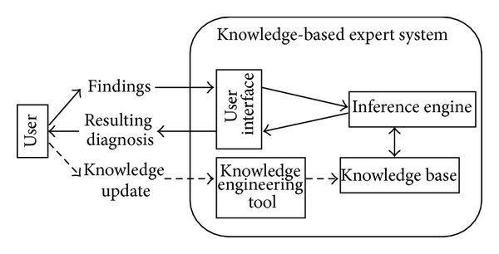
Design
The expert system is a prototype with a case of three diseases that can be diagnosed. The three sampled diseases are common cold, pneumonia and malaria. Each of the diseases has a list of possible symptoms that can easily identify it thus can be used in the diagnosis. The expert system will contain four main parts using rules:
- Specific knowledge base system called Expert.js with rules. It can manage a collection of concepts and their relationships. It can be used to generate insights from otherwise unrelated bits of knowledge. A domain is needed to start using the Expert.js, this domain object contains a single semantic network of objects and relations which are interlinked. If the relation is transitive, the program needs to recur the relation path through all linked concepts. E.g.
Concept.prototype.fact = function (relation, linkedConcept) {
Fact (this, relation, linkedConcept);
return this;
- An inference engine that infers the given information after interaction with users plus the rule base. The interpreter at this point will match the cases based on the interaction and rules, do a conflict resolution if any arises and finally act upon produced inference. It will traverse all the semantic networks created to find the best fit and return the results.
- A way to connect with the users i.e. user interface. It has a very simple interactive face that will be able to give immediate feedback depending on the symptoms that have been passed. Basically the user lists up to but not necessarily five symptoms then it can give the possible diagnosis. The more symptoms you list the more specific the case becomes and hence the right diagnosis is made.
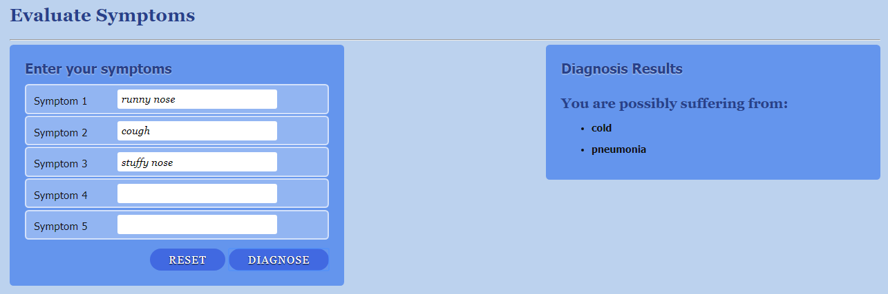
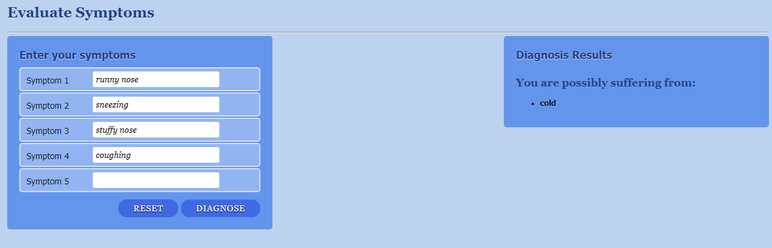
- A temporary working memory that will be used for processing purposes.
Knowledge Representation
The system uses rules that makes use of an inference engine. With the use of an inference engine, translation is needed for knowledge about a specific disease. A record of the background of the medical situation, disease, is captured through interviews with the medical doctors as well as some patients. After recording, a number of rules are created that contain the IF part which handles the possible symptoms and the THEN part which shows the disease with that symptom. Inference engine which has some reasoning provides a way through which the system selects the rules to fire at given intervals i.e. when it traverses the semantic network to get a match for the disease, as diagnosis takes place. It tries to match the input data which are the facts (symptoms) about the disease with rules that are applicable from the knowledge base. At the end the inference engine provides the disease associated with the symptoms. The expert system is able to store heuristic knowledge thus interaction with it by the user to solve a situation, it can be consulted as it can avail the diagnosis in a very short period. The final conclusion about the diagnosis can be done based on the responses given by the patient to the specific questions asked by the expert system as its entered. The responses will be part of the facts that are stored to be added later if any new symptom is discovered plus the system inference. All this will be processed to extract rules hence finalizing on the creation of the knowledge base.
Knowledge Base
Inference Engine
Working Memory
Expert system
User Interface
Suggest
Suspend

Conclusion
Knowledge of the few medical specialists can be utilized in times of extreme necessity. Expert systems will extract and store this knowledge and utilize it whenever it’s needed. Getting information for the knowledge base will be quite tough and maybe in future the database should have a better database for hospitals which can help in generation of data for diagnosis using machines. A trained expert would be needed to validate the quality of the diagnosis that the system performs.

References
- Knowledge Representation for the Nursing Diagnosis By Means Of An Expert System by M. Lourdes Jiménez, José M. Santamaría, L.González1. Á.L. Asenjo, L.M. Laita, M. Beamud
- D. Moher, A. Liberati, J. Tetzlaff, D. G. Altman, and P. Group, “Preferred reporting items for systematic reviews and meta-analyses: the PRISMA statement,” OpenMed, vol. 3, no. 3, pp. e123–e130, 2009.
- Azaab S., Abu Naser S., and Sulisel O.,2000. A proposed expert system for selecting exploratory factor analysis procedures, Journal of the college of education, 4(2):9-26.
- Russell, S. and P. Norvig, 2002. Artificial Intelligence: A Modern Approach, Prentice Hall, Second Edition.
- Beverly G. Hope, Rosewary H. Wild, « AnExpert Support System for Service Quality Improvement», Proceedings of the Twenty-Seventh Annual Hawaii International Conference on System Science, 1994.

